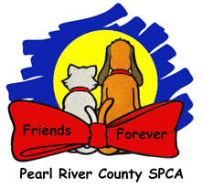Use of Protective Clothing

We use protective clothing during activities of extreme animal handling: Cleaning, heartworm testing, and start meds. The intent of this practice is to minimize the spreading of disease thru the shelter. The protective clothing consists of scrub pants, removable upper wear, and lab coats.

Staff should apply the protective clothing when beginning any of these activities and remove the clothing immediately after completing the tasks. Clothing used for any of these tasks should not be worn any place in the shelter after having completed the assigned tasks as doing so presents the possibility of tracking disease anywhere the staff travels.

Soiled clothing should be presented for washing daily.

Clean clothing should be folded, sorted by size, and placed in the clinic lockers.