 ***Intake Tickets***

**Remember to take a picture that captures the ticket number.**

**Remember to take a picture of the dog.**

**Please make sure that all the highlighted, animal specific items are filled out during intake.**

Your Initials

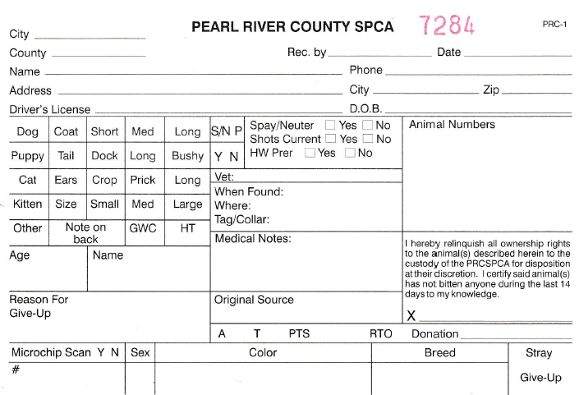

SFS

Primary / Secondary color

If the animal is a stray and is wearing a collar, please describe the collar color on the intake ticket.

The collar itself must be removed, labeled with pet ID# and date, then given to receptionist.

If you have deviated from the standard intake medications, you must write changes in the Medical Notes section. examples: "no intake given" "up to date" (must be verified by Beth, Judy, or Debi)

Obvious medical issues at intake: "skin issues" "limp-back right" "open sore on back"