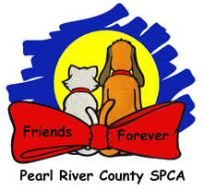Kennel Cough Fact Sheet

**What is kennel cough?**

Kennel Cough is a highly contagious, bacterial respiratory infection commonly caused by the Bordetella bacteria.

**How is it transmitted?**

Kennel cough is transmitted through airborne droplets, direct contact, or contaminated surfaces such as water and food bowls.

**What are the signs?**

Strong cough often a “honking” sound, green/yellow runny nose, sneezing, lethargy, loss of appetite, and low fever.

**Which Dogs get it?**

Dogs of all ages are able to get kennel cough. Puppies and dogs with a weakened immune

system are more susceptible to contract kennel cough.

**How is Kennel Cough treated?**

Here at PRCSPCA we treat kennel cough with an antibiotic called doxycycline. However,

pregnant or nursing mothers and puppies under 8 weeks require alternate treatment

medications.

**How is Kennel Cough prevented?**

Kennel cough is prevented by administering the Bordatella vaccine to every dog and puppy upon arrival at the shelter. Unfortunately there are many strands of this bacteria and the vaccine only covers a few of them. Using gloves while handling the dogs with kennel cough as well as changing gloves between dogs will help reduce the spread of kennel cough. Always using proper cleaning and sanitation protocols also helps to drastically reduce the spread of this infection from one dog to another.