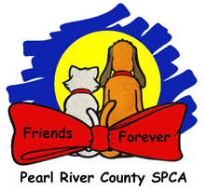

End of Day Checklist

Yards: Emptied of dogs, bowls, toys, and poop

Clinic: Lights, A/C and scale turned off

Puppy scale sanitized and locked

Medicines properly sealed and stored

Sink clean and empty

Floor mopped, trash emptied

Counters clean and sanitized

Gates, closed and locked

Bring Medical Schedule to front desk

Kennels: Full, clean water bowls

Cage clips secured

Clean, Appropriate bedding

Do the Run doors need to be closed?

S/N: Crates made and labeled with kennel locations

s/n clips on cages, and food removed

Lights Out: Clinic, Break Room, Dog Runs, Kitchen, Laundry room, Meet & greet

Locked: Clinic, Inner Gate, Sheds, Break Room, Grooming Room,

Run doors, Office doors, Outer Gate