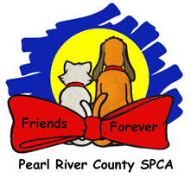 DOG Fight Protocol

**What to do when a dog fight happens?!?**

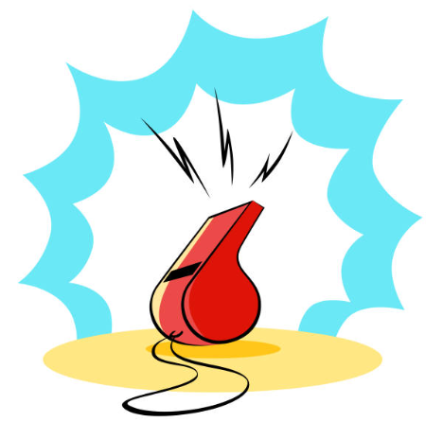**DO NOT**

1. DO NOT PANIC
2. DO NOT GRAB A COLLAR -YOU WILL GET BIT!
3. DO NOT YANK DOGS APART IF ONE IS LATCHED ON

**INTERVENTION LADDER**

1. Blow your whistle
2. Get another person who can help you
3. Distract and startle the dogs
   1. Shake can
   2. Air horn
   3. Water bucket
4. Use any physical barrier to separate the dogs
   1. Igloo house
   2. Kuranda bed
   3. Crate door
   4. Plywood board
5. With a partner
   1. Get a leash on the dogs if possible
   2. Grab the dog under the rear hips
   3. Lift and step backwards
   4. Spin around 180 degrees to break the dog’s focus
   5. Immediately control the dog and remove from situation