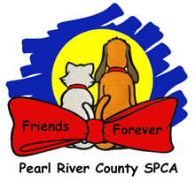Canine Path to Release

PRCSPCA intakes over 3500 animals per year. In order to maintain this level of capacity it is critical that each animal moves through the shelter as quickly as possible and each day an animal spends in our care is for a purpose on a specific outcome plan. There are several paths that lead toward a live release; adoption, transport, or transfer to rescue partners.

Increasing Live Release

INTAKE

1. Make decision on Owner Surrender the day they come in:
   1. Live Release:
      1. Start meds same day
      2. BOA as part of start meds
      3. Take and post pictures
   2. Not Sure:
      1. Change Stage in PetPoint to EVALUATE
      2. Make decision and act within 3 days
   3. Not Adoptable and not Transport eligible:
      1. Euthanize same or next day
2. Make decision on Strays the day they come in for when Stray Hold is over
   1. Schedule a Live Release – HW test and possible BOA while on stray hold
   2. Schedule as Not Adoptable and not Transport eligible
   3. Stray Period over:
      1. Live Release:
         1. Start meds same day
         2. BOA as part of start meds
         3. Take and post pictures
      2. Not Adoptable and not Transport eligible:
         1. Euthanize same day

ADOPTION

1. If the animal is already s/n, it will go home the day it is adopted
2. If the animal is not s/n, schedule the first available vet appointment during adoption
   * 1. Females go to Dr. Smith on Tuesday or Thursday
     2. Males go to Dr. Odom on Wednesday